Dynamic Source Routing with Energy Awareness using a Rule Based Expert System
Steven Baylor, Jeffrey Corcoran & Alexander Maskovyak
Introduction to Artificial Intelligence – R.I.T.
Graduate Class Research Project
July 24, 2008

Outline
- Abstract - DONE
- Introduction and Overview - Jeff
- Research Project Goal: Feasibility study of DSR + Energy Awareness using an Rule based Inference Engine - Jeff
  - Why we wanted to use an inference engine to implement the protocol
  - What aspects of the Mess Networks does our project demonstrate
  - What our system will model “Network protocol”
  - Scope – every aspect of the system. Its saying how much we did. AKA we designed x and x and x to.
- Background Information - Alex
  - What is an Ad-hoc network
  - What is DSR
  - What is Energy Awareness
- Architecture and Implementation - Steve
  - How “Simple” our complex protocol ends up when using JESS
  - What our system models – Network layer protocol that communicates with the Data link & Transport layer
    - Route/Path discovery
    - Energy/Battery Metrics
  - Inference Engine/ Rules processing engine
    - JESS
  - Necessary objects & UML
    - Network, Frames, Datagram, Segment, etc.
  - Design methodology
    - We want to discuss how we determined our rules from our decision tree - STEVE ALREADY DID THIS
- Research problems -
  - Expert System vs Intelligent Agent discussion - Jeff
    - Our system uses rules to mimic a protocol… not necessarily an Expert in a human domain.. so we call it an intelligent agent
  - DSR & Energy awareness processes - Alex
    - Path Discovery sub protocol
    - Path maintenance sub protocol
    - Message propagation sub protocol (also includes appending energy heuristics)
  - Creating rules in JESS –Steve
    - Remember how we had to handle lots of processing in the Java Agent because we couldn’t store everything in JESS.
  - Transmission distance – In real life, we would have to rely on the data link layer to provide this information. – Jeff
- Conclusions of actual implementation of our system – Alex
  - What we learned about energy awareness in our implementation
  - What further research/project implementation “could” we pursue

Abstract

Most networks are composed of stationary devices utilizing fixed connections and trade off high-energy usage for improved performance. Recently, non-static networks often referred to as Ad-Hoc Networks, have multiplied due to the explosion of mobile devices, namely cell phones and other wireless communication devices. Contemporary protocols such as TCP/IP have dominated fixed networks for years but make use of continuous network support message exchange to maintain network statistics used for routing operations. This energy unaware message sending and delivering process is not well suited to ad-hoc networks where data transmission is expensive in terms of energy utilization. Highly mobile devices have an energy storage system consisting of one or more batteries that provide a finite capacity for information exchange. While performance is the primary objective in traditional fixed networks, mobile networks trade off performance to minimize energy drain which in turn can promote the final network life of each device.

Introduction

Our research will attempt to address two goals. Our main goal is to model the Dynamic Source Routing, DSR, protocol using a rule based expert system. In addition, we would like to extend the capabilities of Dynamic Source Routing protocol to provide a limited amount of energy awareness to improve energy utilization. DSR is commonly implemented in situations where a network is non-static and uses an as-needed route discovery algorithm. Our variant of the protocol would be suited for use with stationary wireless devices where no centralized router is present. We generalize our system for use on a wireless mesh network such as a set of motion sensors that are laid out so that the farthest sensor cannot directly communicate with any reception station for information processing. In this scenario XXX

Research Project Goal – Jeff (mix this section with the introduction)

We will use JESS to implement rules needed by our energy aware variant of the DSR protocol. Rules will allow us to easily model the decisions needed when routing data in a dynamic network. Java will provide us the capabilities to model the virtual objects in a mobile network. While our DSR implementation is a virtual network layer protocol in the 7-layer approach to the networking topology, we will also need to interact with actors such as Nodes, a Network, various networking layers, different forms of data encapsulation packages etc.

Description of DSR - Alex

Description of Energy Aware Routing - Alex

Architecture & Implementation

Researching the data exchange process of Dynamic Source Routing has enabled our team to develop the decision processes needed to support on-demand route discovery and energy awareness. Per the requirements of our conglomerate project, below you will find a link to our SVN source code repository.

Project Scope and Issues

As the primary goal of our research is to show whether DSR can be modeled with a rules based Expert System, the scope of our project is quickly exceeding the scope of our allotted time frame. We understand that our final submission will likely not outweigh the real world capabilities of a modern DSR implementation. Due to the unavoidable need of support objects for testing the capabilities of our system, we would be satisfied to show that our system is capable of handling incoming “messages” in an ad-hoc network through example and that we can sufficiently build those routes through the network for data transmission. Aside from this preliminary report, we plan to present a working rules based system to model DSR and demonstrate our understanding of the development process.

The following assumptions are considered in order to maintain a reasonable level of complexity. - Steve

- Transmissions are omni-directional. In other words, a transmission at a given power level can be received up to the same distance in all directions.
- Nodes are configured in a two dimensional plane. There are no obstructions between the nodes.
- Transmissions decrease the energy level of a node’s battery. The amount of energy that is decreased from the battery is proportional to the power at which the transmission is broadcast. The size of the transmission does not affect the energy consumption of the node. Receiving or processing messages do not affect energy consumption.
- The distance at which a transmission can be received by another node has a logarithmic relationship to the power at which the transmission was broadcast.
- All nodes have equal transmission and reception capability. The maximum transmission power and range is the same for all nodes and the transmission cost from one node to another, is equal to the transmission cost in the other direction.
- As a simplification Nodes are stationary. Once a node learns the distance between two nodes, the distance does not need to be updated.
- A node knows the distance, or corresponding transmission power, to the node from which it received a datagram. In other words, the receiving node knows the distance from the source node. This information is given to the receiving node by the Network object. For example, a datagram is sent from Node A to Node B. Once Node B receives the transmission, B now knows the distance to A. The sender, A, does not know the distance to B as a direct result of the transmission. The cascading of distance information is explained in the description of the protocol. We assume that learning distances between nodes is possible in application, but the implementation of this detail is not the goal of our project.

Rules:

Message from User:

If a node receives a command from an application to send data to another node in the network, the agent has to decide if a path exists to the desired destination. If a path does not exist, the node will initiate and transmit a datagram of type “Route Request” or “RREQ”. The RREQ datagram contains the ID and battery metric of the originating node as well as a destination, but does not contain any message or path specification. The intention of sending a RREQ is that a “Route Reply” or “RREP” will be received which will provide a valid path to the destination. At that point, the message can be transmitted though a “Data” type datagram.
It is possible the node is already aware of at least one path to the destination. If more than one possible path exists, the node has to decide which path to choose. This is done by calculating a cost for each possible path and choosing the path with the minimum cost. The cost is calculated through a mathematical formula, which takes into consideration the most recent battery metric information, for each node in the path, and the transmission cost between each adjacent node in the path. Battery metrics are determined by a function of the node’s battery capacity and current level of charge, and are communicated to other nodes through datagrams. The cost of the transmission between two nodes is proportional to the power at which signals between the two nodes must be transmitted and is related to the distance between the nodes. This information accumulated and stored by the agent. Specifically, the cost of sending a datagram from node n_{x} to node n_{j}, using the path n_{x}, n_{x+1}, n_{x+2,} … , n_{y} is 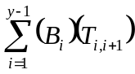, where B_{k} is the battery metric of n_{k}, and T_{k,m} is the transmission cost between n_{k} and n_{m}.
Once the node has determined the path that a message should take to reach the destination, the agent builds the datagram. The datagram consists of the message, the node’s own ID as the source, the destination, the path, and the estimated battery metrics for all the nodes in the path.
The estimated battery metrics that are attached to the datagram are the most recent information that the node has about, about the other nodes along the path. Although these battery metrics will be out of date, and therefore over-estimations, the information is provided so nodes along the path, which may have even less recent metrics, can get the updates. These battery metric estimations are updated by the corresponding nodes in the path, as the datagram is propagated. This is detailed in the section related to datagram forwarding.

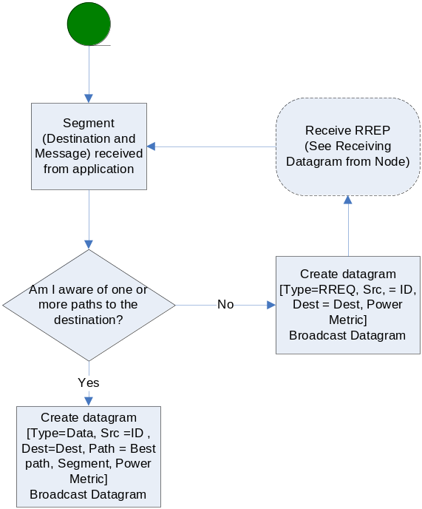

Receiving datagram:

When a node receives a datagram, regardless of the type (i.e. RREQ, RREP, or Data) the node needs to extract and update the battery metrics and transmission costs that may be provided in the datagram. The datagram may also contain new information relating to the network topology, which should be extracted by the node in the form of paths from the node to other nodes.
There are three possible cases regarding the node’s position in the path of the Datagram. In the first case, our node ID is the last node in the path of the Datagram and is therefore the destination. In this case, the reverse of the datagram’s path is a valid path back to the source of the datagram, and is stored. Likewise, the node also stores paths to each intermediate nodes on the datagram path’s. For example, if a datagram has a path, A-B-C-D, then node D stores paths D-C-B-A, D-C-B, and D-C.
The second case is that the node is in the path, but is not the last node in the path. In this situation, the node can extract paths to each node before itself in the path as well as each subsequent node in the path. For example, if a datagram contains paths A-B-C-D, then node C stores paths C-B-A, C-B, and C-D.
The third scenario is that the node is not in the path at all. This occurs if the node is within transmitting distance of one the nodes in the path, and eavesdrops on the datagram. In that case, the node can extract paths to each node in the path, through the node from which it received the transmission of the datagram. If node F receives a datagram from node C, containing the path A-B-C-D, it stores paths F-C-B-A, F-C-B, F-C, and F-C-D.
After the transmission cost, battery metrics, and new paths are extracted from a datagram, the agent must decide what to do with the new datagram. First the agent inspects the type.
If the type is “RREQ”, the agent then checks if it is the destination of the RREQ. If it is not, then the agent appends its own ID to the path, as well as appending the battery metric and the cost of the transmission between itself and the node from which the datagram was received. The node then transmits the updated datagram.
It is possible, and likely, that nodes will receive the same RREQ from more than one other node. The same RREQ should be forwarded only once by any single node, to avoid redundancy. Therefore, the RREQ datagram has a RREQ identifier which will be stored by each node who receives the RREQ.
If the node is the destination of the RREQ, then the agent changes the type of datagram from “RREQ” to “RREP”, and reverses the path, battery metrics, and transmission costs that were built up as the datagram cascaded through the network. The node then transmits the datagram.
If the datagram that’s received is of type “RREP” then the agent checks if it is the destination. If it is the destination, then the agent now has a path to a node which is the destination of a data message, and can now append that path to the message and send it. If the node is not the destination, it inspects the path to see if it in the path.
If the node is not in the path, then the agent does not do anything further with the datagram. If the node is in the path, then it updates its battery metric to the datagram and transmits the datagram.
When a datagram is received by a node has type “Data”, the agent checks if the node is the destination of the datagram. If it is, then the message is given to the application. If the datagram is not the destination, but the node from which the datagram was received precedes the node in the datagram’s path, then the datagram is transmitted by the node. If the node is not in the datagram’s path, nothing is done with the datagram.

